CHOP-SAT Notes

26 July 2022
Why does mean of feasible region projections onto axes qualitatively match the atom probabilities for Wumpus World?
For large n, most complete conjunctions are near zero probability; the feasible region points with projected extrema towards 0 or 1 in in the same hyperplane as any solutions with that assignment to the atoms. Thus, the highest probability assignments are sampled.
28 July 2022
The prob of an atom can be fixed by setting the min/max constraints in linprog (i.e., set both to the desired value).
Developed new multi-speed strategic deconfliction algorithm:
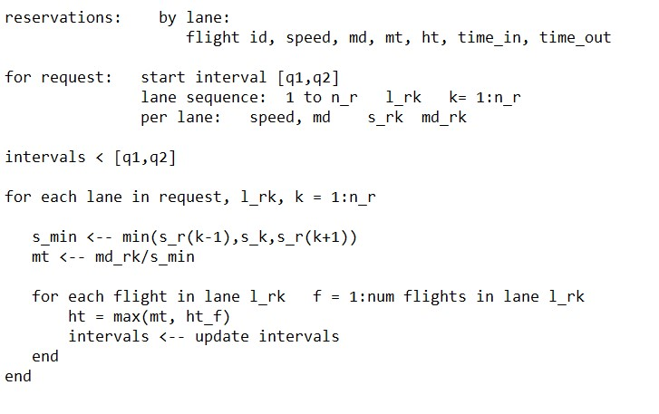

and an associated test problem:
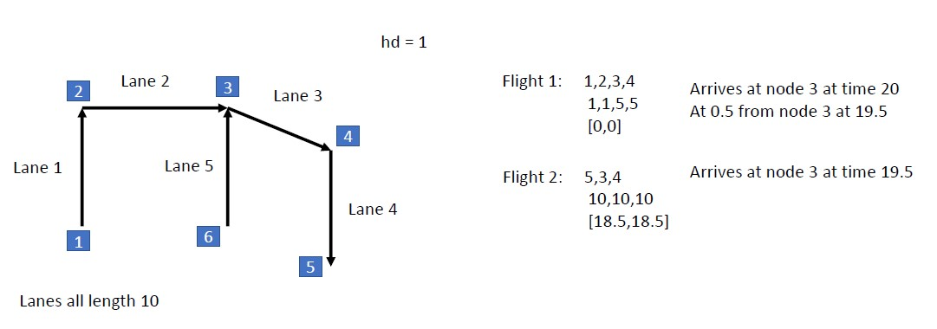
Trace of problem:
reservations is empty
flight 1: lanes (1,2,3,4), speeds (1,1,5,5), hd (1,1,1,1) [q1,q2] = [0,0]
lane 1
s_min = 1
mt = 1/1 = 1
intervals = [0,0] (no reservations)
lane 2
s_min = 1
mt = 1/1 = 1
intervals = [0,0]
lane 3
s_min = 1
mt = 1/1 = 1
intervals = [0,0]
lane 4
s_min = 5
mt = 1/5 = 0.2
intervals = [0,0]

For flight 2:
reservations.lane1 = [1,1,1,1,1,0,0] id,s,md,mt,ht,t1,t2
reservations.lane2 = [1,1,1,1,1,10,20] id,s,md,mt,ht,t1,t2
reservations.lane3 = [1,5,1,1,1,20,30] id,s,md,mt,ht,t1,t2
reservations.lane4 = [1,5,1,1/5,1/5,30,40] id,s,md,mt,ht,t1,t2
flight 2: lanes (5,4,3), speeds (10,10,10), md (1,1,1)

lane 5
s_min = 10;
mt = 1/10 = 0.1
intervals = [18.5,18.5] no other flights in lane 5
lane 3
s_min = 10;
mt = 1/10 = 0.1
flight 1 is in lane 3
ht = max(0.1,1) = 1
intervals = empty since ht 1 overlaps with flight 1 time
no reservation possible!
Wrote function: LEMNOT_test_MSSD that generates corresponding airway
30 July 2022
Amelia is studying impact of changing min and max constraint values in linprog call.
Issues:
- Is SAT solution found?
- How many unique solutions are found?
- How good is the atom mean probability?
Note that the min/max constraints can be used to set atom probabilities (i.e., equating them to the desired value)
Another idea: Use mean projection to select atom with closest value to 0 or 1; round it; fix it and rerun linprog; iterate until all atoms are set. Is it a solution?

6 August 2022
Amelia: PSAT Inference
KB families: 1only1, just1, WW
- Explore min/max constraints
- Write compact_KB
- Study linear programming
- Write 1only1 test (min/max params)
- Convert SAT competition files to KB data structure
Research Questions
- What sort of atom probability approximation is the mean of the feasible region points associated with the extrema projections on the atom axes?
- As # sample points infinity, does mean actual atom prob mean?
- Can Deep Learning be used?
Try on SAT competition KBs
Try on Matt’s colleague’s KB

Tessa: Policy Optimization using probabilities
Ishaan: Linear Programming Issues
Research Questions:
- Can interior point method be modified to expose corner (SAT solution)?
- Any advantage to use non_Euclidean geometry representation?
Create PSSAT Matlab folder
Subdirs:
- Develop
  - Amelia
  - EAGER
  - NILS
  - PSSAT_old
  - Tessa
  - Wasatch100
  - WW_KB
  - WW_sim
  - CNF
- Production
  - CHOPSAT
  - NILS
- Apps
  - WumpusWorld
- Datasets
  - Sc2002benchs
    - …
8 August 2022
Algorithm to solve KB:
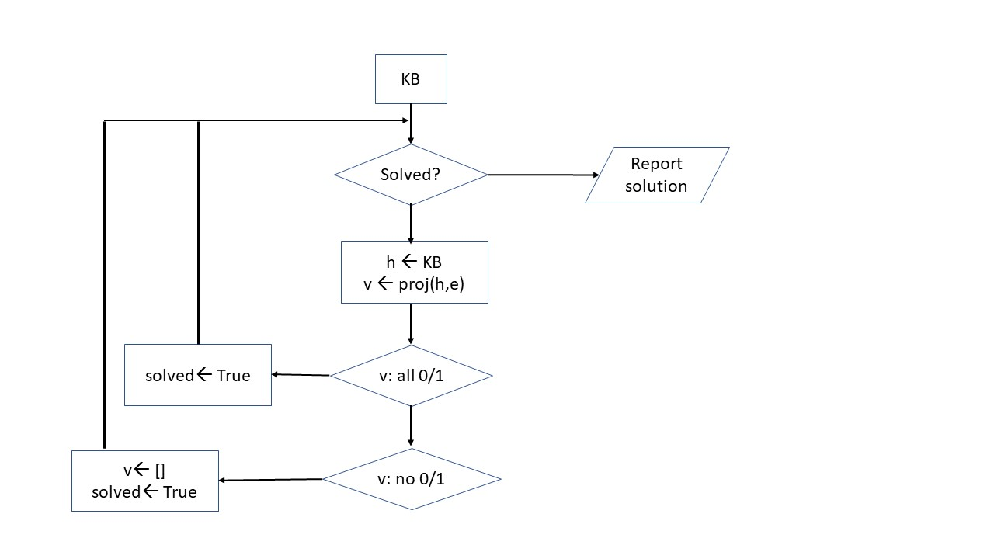
9 August 2022
Amelia: functions to develop:
- rotate feasible region from one axis to another
- test if point in feasible region
- use MC to produce point cloud in feasible region, then fit convex hull to visualize
Ishaan: MCMC convex polytope volume estimation
Use volume to estimate impact of reducing feasible region by chopping singleton sub-hypercubes
10 August 2022
Use Bob Johnson’s 2D vis method to diagram projection points or prob means
1 September 2022
For a given point set is d-dimensional space, to achieve (1+eps) error can be solved in (1/eps)^(d-1/2).
A set of linear inequalities is a dual to points (?) and harder but same complexity (algorithm?)
For volume estimation, “Practical Polytope Volume Estimation”(sun and Freund) says it is possible to get a polynomial time estimate within arbitrary accuracy. They refer to Khachiyan and Todd (1993) who give a method to find an epsilon-optimal ellipsoid (inscribed?) in O(m^(3.5)ln(mR/eps)ln(n lnR/eps)).
Another idea: cut the feasible region at the mid-hyperplane between two n-1 D faces; see it is has the properties of I_(n-1); I_(n) is the largest feasible region for an inconsistent KB (e.g., octahedron in 3D).
Will talk to Paul Rosen Friday (2 Sept) about a poly-time algorithm for min circum ellipsoid for H-polytope.
If minimum circumscribing ellipsoid has max semi-axis length <= sqrt(n-1)/2, then it’s inconsistent.
“Efficient Computation of the Volume of a Polytope in high-dimensions using Piecewise Deterministic Markov Processes” - has C++ code
E (ellipsoid) in R^n is the affine image of unit ball Bn = {u in R^n | ||u||<=1}
E = c + A(Bn) = {c+Au : u in R^n, ||u||<\1} in R^m
A in R^(mxn) c is center of E
Vol(E) = det(A)vol(Bn)
Barnes 1982, Khachiyan & Todd 1993, Zhang and Gao
For $c∈R^{n}and Q∈S_{++}^{n}$ $E_{Q,c}=\left\{x∈R^{n} | {\left(x-c\right)}^{T}Q\left(x-c\right)≤1\right\} and Vol\left(E_{Q,c}\right)=\frac{π^{n/2}}{Γ(\frac{n}{2}+1)}\frac{1}{\sqrt{det⁡(Q)}}$
$$Γ\left(n\right)=\left(n-1\right)! n∈N$$
$$Γ\left(\frac{n}{2}+1\right)= \frac{π^{n/2}}{2^{n}\left(n-1\right)!}n n∈Odd$$
$${Vol}_{n}\left(R\right)≈\frac{1}{\sqrt{nπ}}{(\frac{2πe}{n})}^{n/2}R^{n}$$
So, let $E=\left\{v\right| \left|\left|Av+b\right|\right|≤1\}$
Then the minimum volume ellipsoid is given by:
minimize log det $(A^{-1})$
subject to: $\sup_{v∈C} \left|\left|Av+b\right|\right|≤1$ where C is the convex polytope
rewrite as:
minimize(over Q,c) $det(Q^{-1})$ s.t. ${\left(a_{i}-c\right)}^{T}Q\left(a_{i}-c\right)≤1 i=1…m Q pos\operatorname{def}{matrix}$

let $M= Q^{\frac{1}{2}} z= Q^{\frac{1}{2}}c then:$

min (over M,z) Ψ$\left(M,z\right)=-\ln{\det\left(M\right)} s.t. {\left(Ma_{i}-z\right)}^{T}\left(Ma_{i}-z\right)≤1 M pos def$
is a convex program
if $\left(M,z\right)is a solution, then Q=M^{2} and c=M^{1/2}Z is a solution$

3 September 2022
Distance from corner to hyperplane: $d_{cor,h}=\sqrt{\frac{1}{n}}$
Distance from center to corner: $d_{ctr,cor}=\sqrt{\frac{n}{4}}$
Distance from center to $H_{2}=\frac{{(n-2)}^{1/2}}{2}$
Distance from center to hyperplane: $d_{ctr,h}=\sqrt{\frac{n}{4}}-\sqrt{\frac{1}{n}}=\frac{n-2}{2√n}$
Conversion factor from inscribed to circumscribed: $\frac{\sqrt{n} {(n-2)}^{1/2}}{n-2}$

